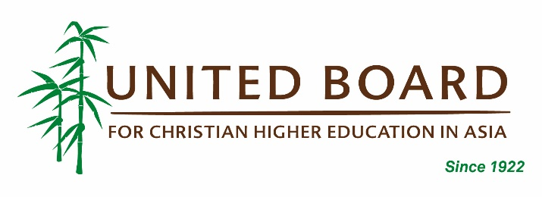
United Board Faculty Enrichment Program
2019 MPI Annual Peacebuilding Training (Non-Degree)
APPLICATION FORM

Please fill out all the applicable information below, as detailed as possible.
PERSONAL INFORMATION
Name: (last name) | (first name) |  |  | (middle name)
Preferred Name: | Gender: |  | Birth Date: (dd/mm/yy)
Email: |  | Phone Number: ( )
Nationality: |  | Current Residence Country:
Mailing Address:
Skype Address (if any):
HOME INSTITUTION
Name of Institution:
Address of Institution:
Department: |  | Job Title/Position:
Employment Period: (mm/yy until mm/yy)
Responsibilities:
EDUCATION
Please list the most recent degree program that you have completed.
Name of Institution:
Degree: |  | Major:
Study Period: (mm/yy until mm/yy)
Country: |  | Language of Instruction:
ENGLISH PROFICIENCY
Identify any English proficiency test you have taken
Test Name: |  | Year Taken & Score:
Rate your English Proficiency (Poor, Fair, Good, Excellent)
Speaking: | Listening: | Writing: | Reading:

OTHERS
Special Dietary Needs (e.g. food allergies)
Do you have any health issues/problems we should be aware of?
Photo /Video Consent: I consent to United Board’s use of photographs or video recording that are taken of me while participating in the Annual Peacebuilding Training for use in United Board’s brochures or program materials that are distributed both in printed form and on the Internet. No payment will be made for use of these photographs. |  |  | Yes / No
COURSE SELECTION
Four or five courses will run concurrently each week, and each participant will only be able to attend one course per week. Please rank your course preferences below, 1 for first choice and 5 for fifth choice.
Please note that the Conflict Resolution Skills: Mediation and Dialogue course and the Digital Peacebuilding and New Media course in Week 2 have prerequisite. Please refer to the Training Information Packet for more details.
Example of preferred courses for Week 1:
3 | FUA – From Understanding to Action: Development and Aid Interventions as Tools for Social Reconstruction and Building Peace
4 | FPB – Fundamentals of Peacebuilding
1 | ICT – Introduction to Conflict Transformation
2 | MaPEC – Mainstreaming Peace Education in Communities and Schools
Week 1: May 13–17, 2019 |  | Foundation Courses
 | FUA – From Understanding to Action: Designing Conflict Sensitive Interventions
 | FPB – Fundamentals of Peacebuilding
 | ICT – Introduction to Conflict Transformation
 | MaPEC – Mainstreaming Peace Education in Communities and Schools
Week 2: May 20-24, 2019 |  | Thematic Courses
 | AACP – Arts Approaches to Community-Based Peacebuilding
 | ANV – Be the Change: Designing Transformative Justpeace through the Power of Nonviolence
 | CRS – Conflict Resolution Skills: Mediation and Dialogue
 | MEPP – Introduction to Monitoring and Evaluation for Peacebuilding Practitioners
 | UCIRP – Understanding Culture and Identity as a Resource for Peacebuilding
Week 3: May 27-31, 2019 |  | Thematic & Field-Based Courses
BT – Bottom-Up Transformation: Experiences and Practices of Grassroots Peacebuilding in
Mindanao (Classroom and Field-Based Course)
 | DTTC – Dealing with Trauma in Times of Conflict
 | IPCB - Indigenous Peoples’ Culture-Based Conflict Resolution Practices: Its Potential Contribution to Mainstream Peacebuilding in the Philippines (Field-Based Course)
 | IRPB – Interreligious Peacebuilding: Approaches for Cooperation, Social Cohesion and Reconciliation

ADDITIONAL INFORMATION
- In 600 words (250 word-minimum), please describe relevant work and personal experience that motivate and prepare you for study at the MPI.
- In 600 words (250 word-minimum), describe your overall objectives for participating in the MPI Annual Peacebuilding Training, and indicate the ways in which you expect to apply what you learned at the training back at your home institution.
- What courses and activities are related to peacebuilding at your home institution?
- Have you participated in other United Board programs or received a grant before? If so, please list all the programs and grants.

I declare that the information given in support of this application is accurate and complete. I understand that any misrepresentation will result in the disqualification of my application for the United Board scholarship.

Signature: Date:

