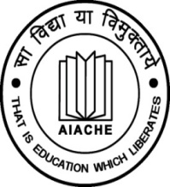
ALL INDIA ASSOCIATION FOR CHRISTIAN

HIGHER EDUCATION (AIACHE)

Ecumenical Centre, 39 Institutional Area
D-Block, Janakpuri, New Delhi - 110 058

Organizes

“TRAINING PROGRAMME IN EDUCATIONAL MANAGEMENT”

A WORKSHOP ON STRATEGIC ACADEMIC LEADERSHIP
(for Vice Chancellors/Principals/Managers from the
Member Institutions of AIACHE)

Sponsored by:

10 – 13 October, 2019
(Thursday, Friday, Saturday, Sunday)

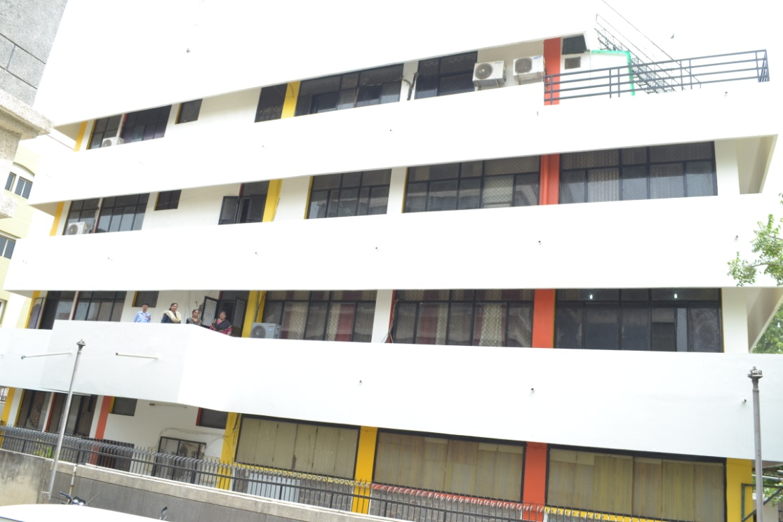
All India Association for Christian Higher Education
AIACHE NEW DELHI

About AIACHE

The All India Association for Christian Higher Education (AIACHE), a national ecumenical organization, was founded in January 1967, to bring together all the Christian institutions of higher learning in India, in order to promote value-based, socially relevant, faith instilled educational process for Nation Building and responsible citizenship training among the youth, both among men and women. AIACHE has celebrated its Golden Jubilee in 2016. Now it aims at leading and training Christian colleges and universities in India in the 21st century with right values, motivation and attitudes. India has above 600 Christian higher educational institutions including State Universities, Deemed to be Universities, Medical Colleges, Engineering Colleges, Arts-Science-Commerce Colleges, M.Ed.-B.Ed. training institutions, Nursing Colleges, etc. The Pioneer institutions in Higher Education in India like St.Xavier’s College Kolkata, WB, (Estd.1816), CMS College Kottayam, Kerala, (Estd 1817), and Serampore Christian College, Hoogly, Kolkata (estd 1818) have served India for over two centuries, with alumni like Swamy Vivekananda and Subhash Chndra Bose. AIACHE is the common venue to voice the strength of these minority institutions.Over the years AIACHE has become the symbol of the deepening of ecumenical spirit and ONENESS in the MISSION of the Churches in India. The concept of mission is understood as the responsibility to bring about COMMUNION among the people, to work for and promote the Biblical and Constitutional values of JUSTICE, FREEDOM, EQUALITY, FRATERNITY and PEACE.

OBJECTIVES OF THE PRESENT WORKSHOP:

(a) To identify the strengths and weaknesses of the administrators in Christian colleges and universities with reference to their knowledge, skills, values and attitudes.
(b) To train the Principals, Managers and Senior Mid-level Faculty in the effective management and extension of their work and to generate better motivation and creativity in them.
(c ) To impart leadership skills, emotional intelligence and soft skills in the personnel with a view to maximizing their productivity and output.
(d) To enable them to achieve the objectives of higher education teaching, research and extension.

REGISTRATION FORM:

The participants need to fill up the following information and send to aiache2011@gmail.com at the earliest to confirm their seats.

- Name of the Applicant: ………………………………………………………………..
- Name and address of the Institution:……………………………………………...
- Personal mobile no. ....................................................................................
- Email ID: ....................................................................................................
- Recommendation of the Principal: ………………………………………………..
Recommended (Name of Principal)
First 30 applicants only will be selected and they will be informed to pay Registration fees by NEFT. Registration fee will be non-refundable.

Last date for receiving the Registration Form is 10th September, 2019
For Further details contact:
General Secretary, AIACHE, New Delhi
Email : aiache2011@gmail.com Mob : +8637338969

PROGRAMME SCHEDULE

Time | Programme Details
Day 1 – 10 October, 2019  (Thursday) | 4.00 P.M. TEA
4.30 P.M. | Registration
5.00 P.M. Opening Devotion  Joel 2: 23-29  Inauguration Welcome  Inaugural Address:  Presidential Address:  Keynote Address:  Introduction of the  National Workshop | Mrs Shirly Michael, Mrs Bindhu Joshua, Mrs Seema  Fr Joseph Puthenpura CMI, General Secretary, AIACHE  Most Rev. Abp Anil Couto, Metropolitan Archbishop of Delhi  Dr V.M. Spurgeon, Programme Director, United Board  Dr Shakeel Ahmed, Joint Secretary, UGC  Fr Dr Xavier Vedam S.J., General Secretary Designate
7.00 p.m. | DINNER
Day 2 – 11 October, 2019
(Friday)
9.00 a.m. Proverbs 4: 1-18 | Worship
9.15 a.m. to 11.00 a.m. | Session - I  Dr. Jeyakar Chellaraj, Former Principal, Bishop Heber College, Trichy  Leadership Strategies in Higher Education Administration  Developing a Strategic Framework for Principals
11.00 a.m. to 11.30 a.m. | TEA
11.30 am to 1.00 p.m. | Session - II  Dr V.M. Spurgeon, Programme Director, UB  Team Building in HE Administration  How to work together for Educational Excellence in HE
1.00 p.m. to 2.00 p.m. | LUNCH
2.00 p.m. to 3.30 p.m. | Session - III  Dr. Jeyakar Chellaraj, Former Principal, Bishop Heber College, Trichy  Conflict Resolution, Legal issues, Public Relations
3.30 pm to 3.45 p.m. | TEA
3.45 p.m. to 6.00 p.m. | Session - IV  Mr Martin Pinto FCA,  Financial Management and Account related Matters
7.00 p.m. | DINNER
Day 2 – 12 October, 2019
(Saturday)
9.00 a.m. Proverb21: 1-14 | Worship
9.15 a.m. to 11.00 a.m. | Session - V  Mr P.J.Thomas IAS, Former Chief Secretary, Former Govt. Secretary for Higher Education, Kerala  Emerging Educational Trends and expectations of the Public from Christian institutions
11.00 a.m. to 11.30 a.m. | TEA
11.30 am to 1.00 p.m. | Session - VI  Fr Joseph Puthenpura CMI,  Former Principal: St Aloysius College Edathua,  St Joseph’s Training College Mannanam,  Mater Dei CMI College, Enathu, Pathanamthitta  Christian Ethos of Administration and Modern challenges/  What is Christian about Christian Higher Edn Institutions?
1.00 p.m. to 2.00 p.m. | LUNCH
2.00 p.m. to 3.30 p.m. | Session - VII  Dr. A. John Peter  Identifying Areas for Future Directions of Higher Education
3.30 pm to 3.45 p.m. | TEA
3.45 p.m. to 5.00 p.m. | Session - VIII  Dr. A. John Peter  Developing Frameworks for College wide Strategic Planning
5.15 p.m. to 6.30 p.m. | Discussions and Clarifications on the process of Strategic Planning
7.00 p.m. | DINNER
Day 4 - 13 October, 2019
(Sunday)
9.00 a.m. Psalms 95: 1-7 | Worship
9.15 a.m. to 11.00 a.m. | Session –IX: Dr. A. John Peter  Finalizing Tools and Concrete Plans for Strategic  Planning in Colleges
11.00 a.m. to 11.30 a.m. | TEA
11.30 am to 1.00 p.m. | Session X: Moderator: Dr Jeyakar Chellaraj  Discussion & Planning for Better Administration in Colleges  Formulation of a STATEMENT for Christian Principals  Distribution of Certificates
1.00 p.m. to 2.00 p.m. | LUNCH - Departure

