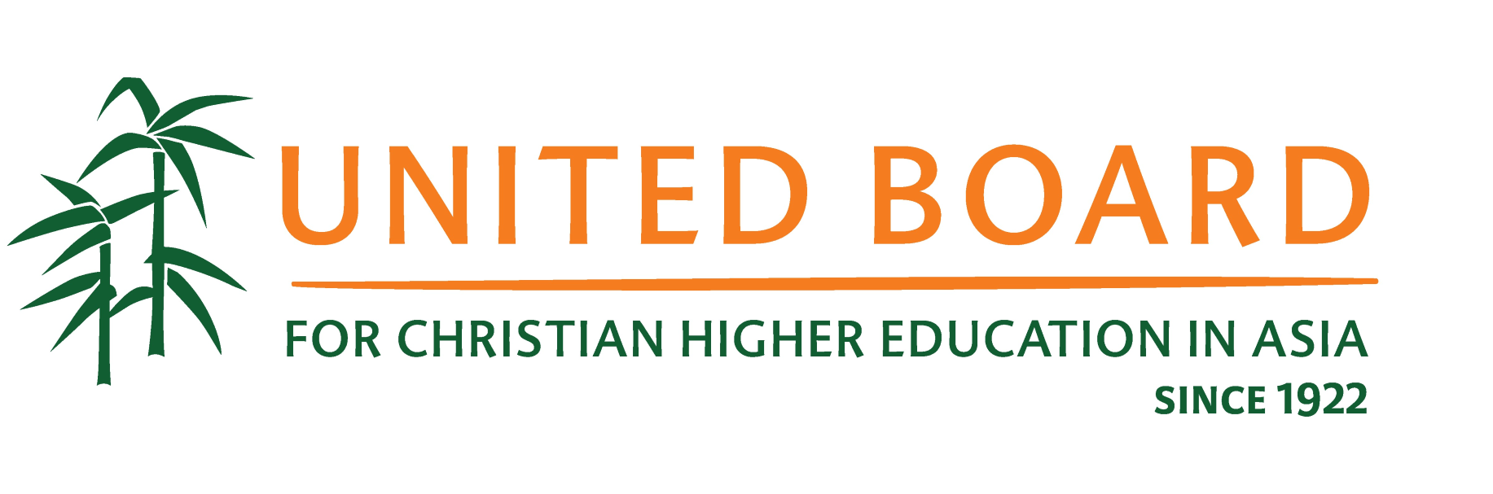

**United Board Fellows Program**

**2025-2026 Application Announcement**

**November 28, 2024**

The United Board Fellows Program is designed to answer the needs of leadership development for mid-career faculty and administrators from Asian colleges and universities. Through this program, the United Board develops dynamic leaders committed to the advancement of whole person education and building strong and resilient academic institutions. Since 2002, over 345 Fellows from 80 institutions in 12 countries and regions of Asia have been selected for this program, and many have played important leadership roles in their home institutions and beyond.

The United Board for Christian Higher Education in Asia is pleased to invite applications for its 2025-2026 United Board Fellows Program.

*“Navigating the Future: Transforming Christian Higher Education in Asia through Innovation, Collaboration, and Leadership."*

This theme highlights the importance of creative and groundbreaking approaches to address the challenges and opportunities faced by higher education institutions in Asia. It emphasizes the need for educators and leaders to develop innovative strategies and leadership skills that will shape the future of their institution while staying grounded in their longstanding mission and values.

Key aspects of the theme include:

1. Exploring emerging trends in higher education and their adaptative implications for Christian institutions in Asia.
2. Developing strategies to enhance the quality of teaching and research in the face of rapid technological advancements.
3. Fostering regional and global collaborations to address common challenges and promote knowledge exchange.
4. Encouraging interdisciplinary approaches and integrating Christian values in addressing contemporary issues.
5. Strengthening leadership capacities to navigate necessary changes and promote continuous improvement within institutions.
6. Nurturing best practices in leadership development and institutional management to ensure sustainable growth and continuous improvement.
7. Integrating Christian values and principles into higher education to promote ethical leadership and social responsibility.

Focusing on the innovative aspect of addressing challenges in higher education institutions while incorporating Christian values in their activities, this theme is supported by three main strands - leadership, innovation, and collaboration, and encourages fellows to critically think about the future of higher education in Asia and develop strategies to address emerging global challenges and sustainability issues.

This one-year experience features a unique higher education leadership development experience, with three main components - an intensive week-long summer leadership institute; a one-to-four-month Asia placement or a two-week study trip in Asia; and a final one-week seminar.

To apply for the Fellows Program, we invite heads or senior leaders of institutions (e.g., rectors, presidents, etc.) or authorized senior administrators to nominate qualified mid-career faculty and/or administrators who have demonstrated the potential to assume larger leadership roles and responsibilities in the future. The United Board selection committee will invite applications based on the quality of the nomination. Each institution can nominate up to **TWO** candidates.

The deadline to submit the nomination is **January 05, 2025**, and all completed applications must be submitted by **February 15, 2025**. We strongly encourage both nomination and application to be submitted through our online portal ([*https://unitedboard.smapply.io*](https://unitedboard.smapply.io)*)*. Please refer to the instructions for the nomination procedure.

Please review the program guidelines for more details on eligibility and the application process. For more information, please visit our website at

https://unitedboard.org/programs/leadership-development/fellows-program/.

**Contact Information**

Dr. Jakarin Srimoon (Program Director)

Email: [jsrimoon@unitedboard.org](mailto:jsrimoon@unitedboard.org)

Dr. Bo Bo Lwin (Program Officer)

Email: [bblwin@unitedboard.org](mailto:bblwin@unitedboard.org)

Or

The UB Fellows Program Team

Email: [ubfellows@unitedboard.org](mailto:ubfellows@unitedboard.org)

United Board for Christian Higher Education in Asia

1/F Chung Chi College Administration Building

The Chinese University of Hong Kong

Shatin, Hong Kong