

United Board Virtual Mentorship Training Asia 2025
Every Wednesday in July (2, 9, 16, 23, 30)
9:30-11:30 AM (HKT/PHT) or 7:00-9:00 AM (IST)

Background

Mentorship has become an increasingly vital role for educators, not only in supporting students but also in fostering career and professional development among peers. Faculty-to-faculty mentoring is especially valuable as it allows those with more training, experience, and expertise to share insights and provide advice to their colleagues. As rapid technological advancements continue to reshape all sectors of society, higher education must adapt—not only in terms of curriculum content, pedagogy, assessment, Whole Person Education (WPE) —but also in the ongoing professional development of its educators.

To address this need, the Faculty Development team of the United Board launched the Virtual Mentorship Training Asia initiative in 2023. This program fosters a collaborative learning environment in which participants engage in a community of practice to strengthen and refine their mentorship skills. The training comprises five interactive, 90- to 120-minute sessions conducted virtually via Zoom and Google Classroom. Each module includes a mix of presentations, small group activities, readings, online discussions, synchronous sharing, case study analysis, and Q&A.

The inaugural workshop series was launched in 2023, facilitated by Dr. Blessing Enekwe and Dr. Spencer Benson. Both have extensive experience in mentorship training, including prior collaborations at the University of Maryland. Dr. Benson has also served as a resource person for several United Board programs on WPE and faculty development.

The Facilitators

Dr. Blessing Enekwe and Dr. Spencer Benson will remain as primary facilitators. In addition, we invited an alum from the previous cohort to provide essential cultural context. The alum co-facilitator this year is Dr. Varbi Roy from the Scottish Church College in India.

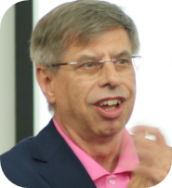  Prof. Spencer A. Benson  Founder-Director  Education Innovations International Consulting, USA  sbenson@eii-consulting.com |   Dr. Blessing Enekwe  Program Director  Office of Postdoctoral Affairs  University of Maryland, USA  blessingo@gmail.com | 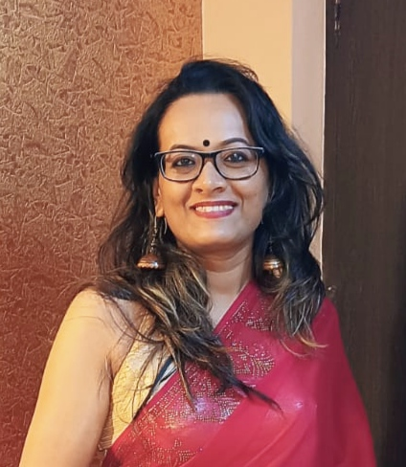  Dr. Varbi Roy  Associate Professor  Department of Philosophy  Scottish Church College, India  vrphil@scottishchurch.ac.in
Expected Learning Outcomes
Prof. Spencer A. Benson
Founder-Director
Education Innovations International Consulting, USA
By the end of this five-session workshop series, participants will be able to:
- Describe the key components of effective mentorship.
- Evaluate various types of mentor-mentee arrangements, their values and limitations.
- Describe strategies for navigating various mentoring scenarios.
- Develop a personal mentoring philosophy statement.
- Come up with action plans for building a culture of mentorship in their respective institutions.

Date | Module | Topics & Activities
2 July | - What does effective mentoring look like? | Facilitators and participants will introduce themselves and begin building a sense of community. The group will explore what it means to learn from one another and contribute to a community of practice. As a collective, participants will define and discuss the characteristics of effective mentoring. Self-reflection and peer sharing of personal mentoring and mentee experiences will serve as a foundation for drafting a personal mentoring philosophy.
9 July | - Mentor-Mentee Relationships and Communication | This session will define and explore various types of mentor-mentee arrangements. Using case studies, participants will analyze challenging mentoring scenarios and identify effective strategies for navigating them. Emphasis will be placed on communication across diverse backgrounds, academic disciplines, power dynamics and cultural contextualization. Strategies for virtual, in-person, and multi-mentor communication will be introduced, with attention to maintaining appropriate personal and professional boundaries. We will explore what it means to be an effective listener. Participants will begin drafting and refining their mentoring philosophy statements.
16 July | - Navigating Difficult Mentorship Situations | This module focuses on how social and cultural contexts influence mentor-mentee experiences. The session will explore how implicit and explicit biases, assumptions, and preconceptions impact these relationships. Participants will examine their own institutional and professional contexts (physical space, research, scholarship, etc.) and how these shape mentoring dynamics. Continued refinement of personal mentoring philosophy statements will be encouraged through peer discussion.
23 July | - Fostering Independence and Career Development | Building on earlier sessions, this module emphasizes strategies to support mentee independence, professional growth, and career planning. Participants will explore both real and hypothetical scenarios that challenge mentor-mentee dynamics and require thoughtful responses. The session also covers the value and challenges of peer mentoring. By the end of this session, participants will finalize the core elements of their mentoring philosophy statements.
30 July | - Wrap-Up – Summary, Feedback, and Next Steps | In the final session, facilitators will summarize key principles of effective mentoring and highlight resources to support mentoring practices. Participants will provide feedback on the workshop series and suggest ways to expand mentorship training across Asian higher education institutions. Each participant will share their mentoring philosophy statement and receive constructive feedback from facilitators and peers.

Criteria for Participants

The faculty members should meet the following criteria:
- They are interested in expanding their knowledge of the role that mentoring plays in whole person education and peer career development.
- They are in position to cascade their learning by sharing with colleagues in their respective home institutions.
- They shall have submitted their application on or before 16 June
- They are duly endorsed by the institution’s head

Contacts
Hope Antone, Director for Faculty Development hantone@unitedboard.org
Jane Chan, Program Manager jchan@unitedboard.org

