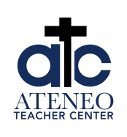 | 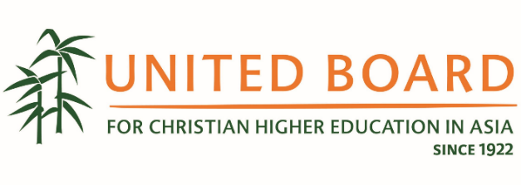
Whole Person Education Academy 2025
“Humanizing Higher Education through Whole Person Learning”

The Ateneo Teacher Center (ATC) and the United Board for Christian Higher Education in Asia (United Board) are pleased to announce that the Whole Person Education Academy (WPEA) 2025 is now open for application.

WPEA 2025 consists of two phases: (a) a twelve-week online course from 6 October 2025 to 9 January 2026, with asynchronous activities and synchronous sessions; and (b) a one-week residential train-the-trainers’ workshop from 4-11 February 2026 at Ateneo de Manila University in Quezon City, Philippines.

After completing the WPEA 2025, participants will be able to:
(1) discuss United Board’s WPE framework and various research-based WPE frameworks;
(2) analyze the implications of WPE for curriculum, pedagogy, assessment; educational innovations; non-academic formation; and research;
(3) analyze change and implementation issues in establishing a WPE framework in their institution; and
(4) plan for a basic training to introduce WPE at their institutions.

Course Schedule and Modules
Dates (weekly) | Module Topic
6-10 Oct  13-17 Oct | Module 0: Welcome to the Course!  Online & Synchronous Session #1 on 10 Oct
20-24 Oct  27-31 Oct  3-7 Nov | Module 1: Whole Person Learning – Why and What?  Online & Synchronous Session #2 on 24 Oct  & Coaching Session #1 on 7 Nov
10-14 Nov  17-21 Nov  24-28 Nov | Module 2: A Graduate Profile for a Turbulent World  Online & Coaching Session #2 on 28 Nov
8-12 Nov  5-9 Jan | Module 3: Teaching and Leadership for Whole Person Education  Online & Synchronous Session #3 on 9 January
4-11 Feb | Residential Course at Ateneo de Manila University  Onsite

Guidelines for Application/Nomination

- WPEA 2025 is open to 12 institutions committed to whole person education and its implementation. In view of this limited number, first-come first-serve may apply in the selection of participants.

- Each institution may endorse up to three participants – consisting of educators and administrators with a commitment to complete the program and are in position to implement action plans in their home institution. A team of three can model interdisciplinary collaboration in implementing WPE at the home institution.

- The institution head (President, Principal, Rector or their designated official) must submit an endorsement letter of their team members. Every applicant will upload this endorsement letter to their online application.

- Interested applicants must speak with their institution heads (President, Principal, Rector or their designated official) to get their endorsement and support to attend the program. The head’s endorsement letter is required to be uploaded to the online application. Every applicant must apply online.

Partnership and Co-Ownership with the United Board

The United Board will cover the costs related to the online course and residential train-the-trainers workshop. However, as a sign of their partnership with the United Board and co-ownership of the program, each institution is requested to cover the travel expenses of their participants.

Institutions that need travel subsidies for their participants must contact the United Board right away.

Last date for application: 22 September 2025
Selection announcement: 29 September 2025

Application Link:

Contacts:
For any questions or concerns related to the WPEA 2025, feel free to contact our team:
- Ms. Jane Chan at jchan@unitedboard.org
- Dr. Cynthia Yuen at cyuen@unitedboard.org
- Dr. Hope Antone at hantone@unitedboard.org

