Strategic Resource Development Workshop
Learning Outcome
- Understanding of why advancement is more than just fund-raising
- Learning about the importance of connecting the strategic plan with fund-raising
Workshop Synopsis – Advancement and Strategic Intent
This workshop explores Advancement and Strategic Intent as a comprehensive, mission-driven practice that goes well beyond traditional fund-raising. Participants will have an understanding that advancement is a strategic function that advances the mission, vision, and priorities of the institution. The workshop also highlights the critical importance of aligning fund-raising initiatives with the institutional strategic plan, ensuring that philanthropic efforts are purposeful, credible, and directly tied to institutional goals.
Resource Generation: Concept and Action- Mr. Ricky Cheng
Learning Outcomes
- Understand the concept of resource generation as a holistic, mission-driven process that extends beyond financial contributions to include relationships, partnerships, reputation, and institutional goodwill.
- Identify key strategic and operational approaches to resource generation, including how institutions can mobilize internal and external stakeholders to support long-term sustainability and impact.
- Translate resource generation concepts into action, developing practical strategies that align institutional priorities with appropriate funding sources, engagement opportunities, and capacity-building initiatives.

Workshop Synopsis – Resource Generation: Concept and Action
This workshop examines Resource Generation as a strategic and integrated function essential to institutional advancement and sustainability. Moving beyond a narrow focus on fund-raising, the session explores how institutions generate resources through purposeful engagement, relationship-building, partnerships, and alignment with mission and strategy. Participants will gain a conceptual understanding of resource generation and how it operates within a broader advancement framework, while also engaging with practical approaches that translate strategy into action. Emphasis is placed on linking institutional priorities with appropriate resource-generation methods, ensuring that efforts are intentional, ethical, and sustainable. Through this workshop, participants will be equipped to think strategically about how resources are cultivated, stewarded, and mobilized to advance institutional goals and long-term impact.

Alumni Relations/Engagement Dr. Bernard Toh
Learning Outcomes:
By the end of this workshop, you will:
1. Understand the strategic importance of Alumni Relations;
2. Gain some ideas how to conduct Alumni Relations/Engagement.
3. Leave with a personalized action plan that you can implement.
Advancement Office – Setup and Challenges - Dr. Meilinda
By the end of this session/ course, participants will be able to:
- Understand the stages and strategic considerations in building an advancement office, from initial preparation and governance to program implementation and evaluation.
- Apply donor-cycle and stakeholder engagement principles: identification, cultivation, solicitation, and stewardship in advancement planning and execution.
- Analyze organizational structure, roles, and responsibilities within an advancement office and explain how each unit contributes to institutional goals.
- Evaluate the effectiveness of advancement initiatives using key performance indicators such as donor retention, alumni engagement, fundraising outcomes, and grant acquisition

Short Bio of Resource people
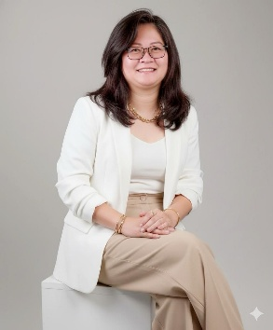
Ms Meilinda: Meilinda is a senior higher-education leader and creative-education practitioner with over 20 years of experience in Indonesian higher education. She teaches in the English for Creative Industry program at Petra Christian University (PCU), Surabaya, where she also served as Head of the Bureau for Cooperation and Institutional Development. Currently she is the Director of the Office of Institutional Advancement. In these roles, she leads international partnerships, fundraising, alumni engagement, and cross-sector collaboration to support institutional sustainability and Whole Person Education. Beyond PCU, she was an active coordinator within Indonesia’s international office association, contributing to national and regional dialogue on global engagement, creative education, and university advancement. Her work bridges teaching, institutional leadership, and international collaboration, with a strong focus on developing human-centered, impact-driven higher-education ecosystems.

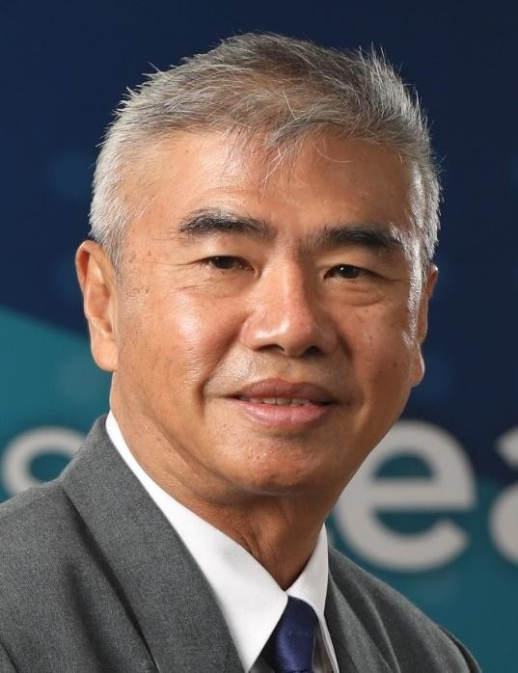
Bernard Toh
Advancement Professional
April 2005 – October 2025

Bernard worked in the area of advancement over the last twenty years at the National University of Singapore and retired very recently. He first joined the National University of Singapore in April 2005 as its Corporate Communications Director. In this role, he oversaw the branding, marketing and corporate communications of the university. In December 2008, he was appointed to the Office of NUS President, leading strategic projects and communications. During this tenure, he also served as Director of the International Alliance of Research Universities (IARU) Secretariat from 2009 to 2013, harnessing the deep talents within ten of the world’s leading research universities to develop and model strategic leadership for the global higher education sector. In July 2016, after eight years in the NUS President’s Office, Bernard was appointed as Director of NUS Office of Alumni Relations to build meaningful, lifelong relationships with NUS’ 330,000 strong alumni family then. After seven enriching years, he relinquished this role and returned to the NUS Office of the President in July 2023 as Director of Special Projects for the next two years. He retired at the end of October 2025 after spending twenty exciting and meaningful years with one of Asia’s leading universities.

Prior to joining the University, Bernard served in the Republic of Singapore Air Force as an air defence professional for two decades, from 1985 to 2005, attaining the rank of full colonel. His highest held command appointment was Brigade Commander before he joined the Air Staff as Chief of Human Resources for the Air Force. In 2001, he was appointed as Director, Public Affairs of the Ministry of Defence, Singapore and served as its chief spokesman. Even after leaving active service in March 2005, Bernard continued to help develop identified high-potential officers through executive coaching and has been actively coaching since 2008.
Bernard graduated from the National University of Singapore with a Bachelor of Arts (Architectural Studies) in 1985 and obtained a Master of Business Administration from Cranfield University, UK in 1998, and a post-Graduate Certificate in Executive Coaching from Lancaster University, UK in 2008. Bernard is in the process of upgrading his coaching credentials with the International Coaching Federation (ICF).

Ricky M. Cheng
Executive Vice President, United Board
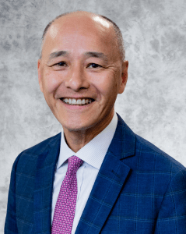
Ricky Cheng was appointed as the United Board’s Executive Vice President in November 2014, following his role as Vice President for Development since October 2010. As Executive Vice President, he continues to oversee development while focusing on strategic planning and special initiatives for the organization.
Before joining the United Board, Mr. Cheng established the Office of Institutional Advancement at The Chinese University of Hong Kong (CUHK) in 2003, where he managed a professional team for all advancement activities. He also has over 20 years of professional experience in the private sector in both Hong Kong and the United States. Ricky was certified as CPA from California and holds an Executive MBA degree from CUHK.

Pareena G. Lawrence, PhD
President, United Board
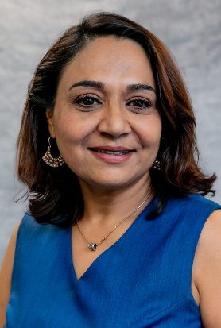
Dr. Pareena G. Lawrence received her bachelor's and master’s degrees in Economics from the University of Delhi, India, and her PhD in Economics from Purdue University. She was Professor of Economics and Management and Division Chair of Social Sciences at the University of Minnesota Morris.
As Provost and Dean of Augustana College, Illinois, and later as President of Hollins University, Virginia, Dr. Lawrence accumulated extensive experience in collaboratively developing and successfully implementing strategic plans focusing on holistic student development, growth, and success of the institutions. She has been a member of many national higher education organizations and boards and deeply engaged with research and trends in higher education, including faith-based institutions.
Before joining the United Board in June 2023 as President, Dr. Lawrence was Senior Fellow at the Office of International Affairs of Yale University, and Visiting Professor and Director of Academic Affairs at Yale-NUS, Singapore.

